21CSS101J – PROGRAMMING FOR PROBLEM SOLVING

CODE COMPREHENSION
REPORT

TEAM MEMBERS:

Section – U2:
- RA2511026011046 - NETRA V
- RA2511026011017 - HARSHITHA G
- RA2511026011044 - ESHAN K THARIK
- RA2511026011043 - SIRAJ EK

PROBLEM STATEMENT:

The system prints numbers 1 to 50, replacing multiples of 3 with “Fizz”,5 with “Buzz”, and both with “FizzBuzz”. Write C and Python programs to preform this task. Explain the effects if the loop begins from 0.

C PROGRAMMING:
Code:
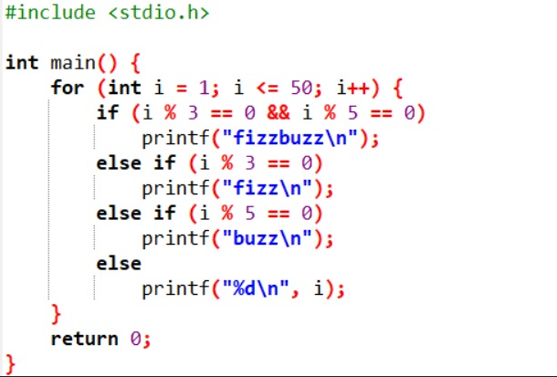

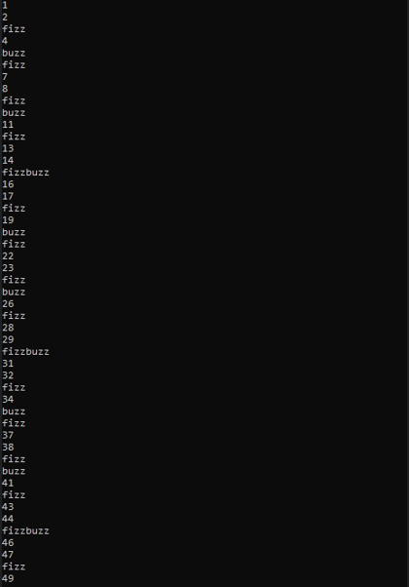
Output:

PYTHON PROGRAMMING:

Code:

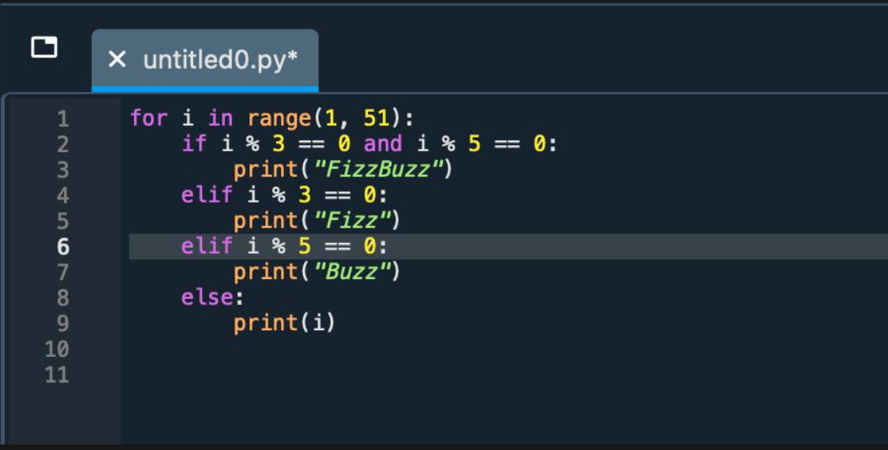

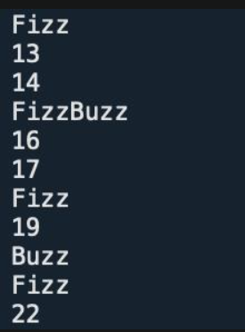
Output:

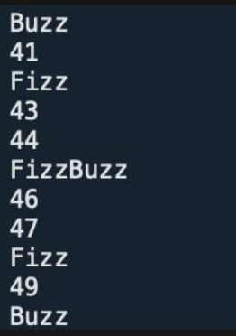
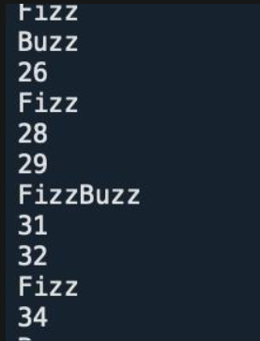
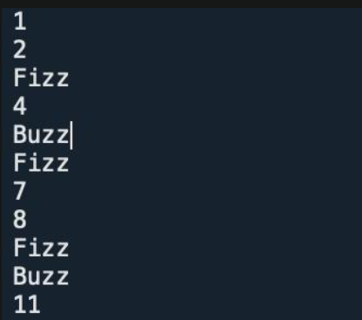

COMPARISON OF C AND PYTHON CODE:
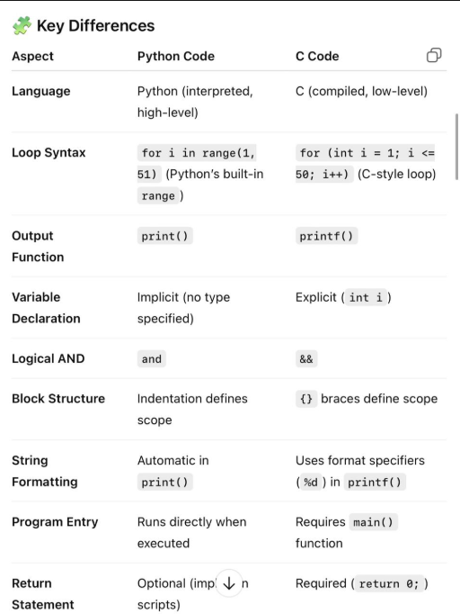

CONCLUSION:

The FizzBuzz program helps us to:

Understand loops (repetition in programming).

Practice conditional statements and logical operators.

Learn how to apply the modulus operator to detect divisibility.

When the loop starts from 1, the logic works as intended.
If it starts from 0, it adds an extra "FizzBuzz" because 0 is divisible by any number — showing the importance of setting correct loop boundaries in programming.

